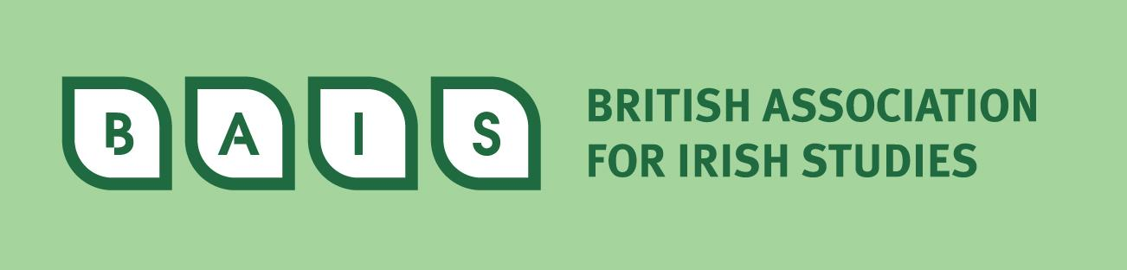

Postgraduate Essay Prize 2026

The British Association for Irish Studies, in association with Irish Studies Review and Cambridge University Press, is pleased to announce the BAIS Postgraduate Essay Prize.

Entries in English and Irish are invited for an essay on any aspect of Irish Studies. Cuirfear fáilte roimh aistí i nGaeilge agus i mBéarla a bhaineann le gné ar bith den Léann Éireannach.

The winning entry will be published in Irish Studies Review and the winning author will receive £500 of Cambridge University Press books of their choice.

Entrants should be student members of BAIS who are registered for Master’s or Doctoral programmes in Great Britain only (England, Scotland, Wales). Essays should be between 5,000 and 8,000 words in length and be presented in accordance with the Instructions for Authors of Irish Studies Review. All essays must be submitted electronically by 17 March 2026. The Prize will be judged by a multi-disciplinary panel. The winner will be announced in May 2026.

Please submit entries to: BAISessayprize@gmail.com
(this email address is for submissions only)

British Association for Irish Studies: https://irishstudies.co.uk/

Irish Studies Review: http://www.tandf.co.uk/journals/titles/09670882.asp

Cambridge University Press: http://uk.cambridge.org/

British Association of Irish Studies - Postgraduate Essay Prize Guidelines

- Entrants should be student members of BAIS who are registered for Master’s or Doctoral programmes at institutions of higher education in Great Britain only. Please note that institutions in Northern Ireland are not included.
- Essays should be between 5,000 and 8,000 words in length and be presented in accordance with the Instructions for Authors of Irish Studies Review.
- Deadline for submissions 17 March 2026. The email address for submissions is: BAISessayprize@gmail.com.
- The Prize will be judged by a multi-disciplinary panel. The winner will be announced in May.

Judging Criteria

The judges will eventually have to compare unlike pieces of work, so the criteria have to be general enough to be applied to all essays, but also particular enough to ensure that those working in the discipline from which the winning essay comes can recognise its quality.

1. General criteria

- An essay which presents an original and publishable contribution to Irish studies, and which with minor corrections may be published in a journal of international standing (Irish Studies Review).
- An essay which will be a worthy recipient of a prize awarded by an internationally respected academic publisher (Cambridge University Press) and presented in the Irish Embassy.

2. Particular/subject-specific criteria

- The quality of the research-methods
- The clarity of the writing (bearing in mind that it will be read both by a specialist and a wider scholarly audience)
- The originality of analysis
- The originality of the conclusion

3. Ranking

If there is more than one suitable candidate from within a specific discipline according to the general criteria, they will be ranked by subject specialists in the light of the particular criteria.

4. Comparing equally ranked entries and final judgement

Essays which fulfil all the criteria above and are ranked equally excellent by subject-specialists will be re-read by the whole panel. They will comment on in them in the light of the following criteria:

- An essay which makes a contribution to Irish Studies as a whole.
- An essay which shows an awareness of issues in related disciplines within and outside Irish Studies
- An essay which will convey the excellence of Irish Studies as a whole to the broader scholarly community.

Please address any queries to Professor Matt Campbell, University of York, matt.campbell@york.ac.uk

